**CIS-350  
Infrastructure Technologies**

**Lab 1 Report**

**Student Name**: **Damon Quire**

1. Insert the *Lab1_Tree* file from p. 24 of the Lab1 instructions into the space provided or use the *Alt-PrtScr* keys to capture the full screen output (full window) from command *TYPE Lab1_Tree* on p. 24 and paste that window here.

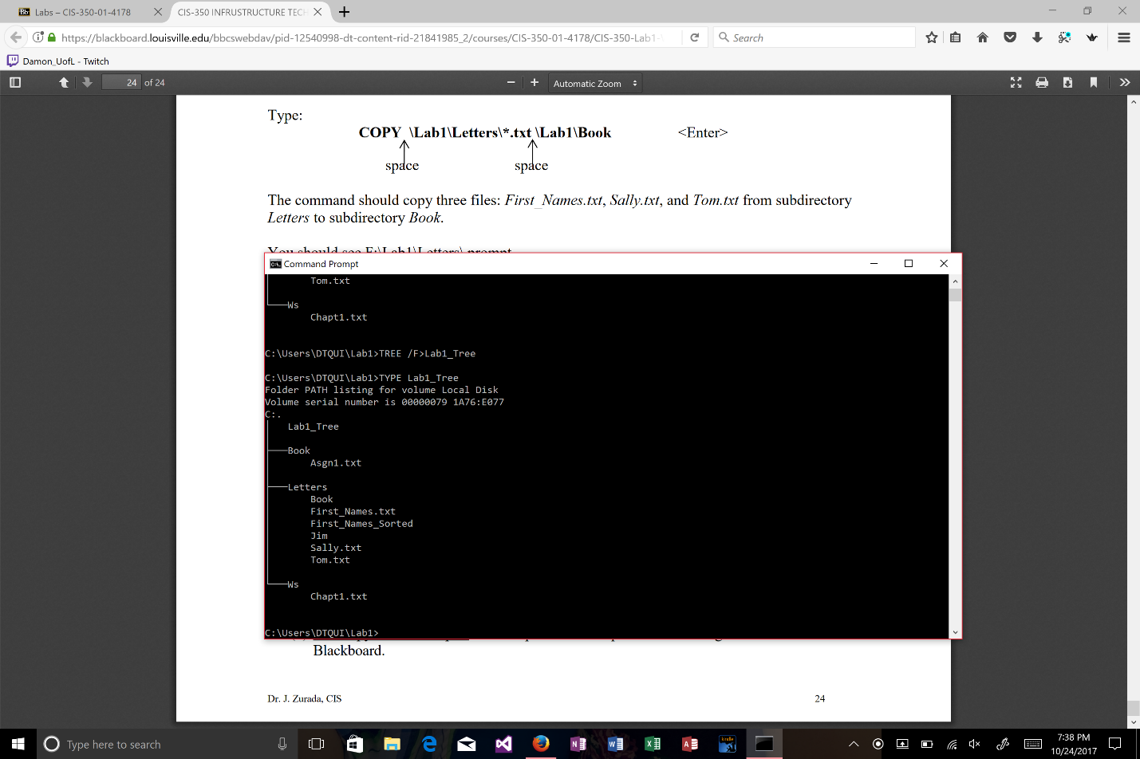

1. You have the following directory structure. ROOT (replaced by "\"), LETTERS, BOOK, BUSINESS, PERSONAL, CLUB, ROTARY, and JCC are names of directories/subdirectories, whereas MEMBER.1, MEMBER.2, and MEMBER.3 are names of files. Assume that the root directory ("\") stores the following files: *Go.bat*, *Paper1*, *Paper2*, *Paper3*, *Sheet1a*, *Sheet2*, *Sheet3*, *Sheet4*, *Shell1*, and *Shell2*. The system prompt displays"C:**\**>" which means that the current drive is C and the current directory is the root directory "**\**".



In the diagram above the word ROOT represents the root directory, i.e., "**\**". In all commands below, use the backslash "**\**" to represent the root directory. Do not to use the word ROOT. The root directory "**\**" is just the origin for other directories/subdirectories. All questions (a) through (j) are based on the above diagram.

1. Write a command to copy file *Go.bat* to directory *PERSONAL*. The copied file should have the same name as the original file.

COPY GO.bat \Letters\Personal

_______________________________________________________________________

1. Write a command to copy a file *Go.bat* to directory *BUSINESS*. The copied file should have new name *Go_copy.bat*.

COPY GO.bat \Letters\Business\Go_copy.bat

_______________________________________________________________________

1. Write a single command to copy all files starting with *She* to directory *BOOK*.

COPY “She*” \Book

________________________________________________________________________

1. Write a single command to erase from the root directory all files that have digit *1* in their name.

DEL “*1*”

________________________________________________________________________

1. How many files would be erased by the command from p. (d) above?

3

1. Assume that *Paper3* is a large file. What command would you use to display the contents of the file one screen at a time (to prevent the output from scrolling off the screen)?

TYPE Paper3 | MORE______________________________________________

1. Write two separate *SORT* commands. Both commands would accept input from file *Paper1*. However, the first command would route the output to file *Paper10*, and the second one would append the output to file *Paper10*.

Routes output = TYPE Paper1.txt > Paper10.txt

Append output = TYPE Paper1.txt >> Paper10.txt

________________________________________________________________________________________________________________________________________________

1. Look at the diagram. Assume that prompt "C:\LETTERS\CLUB>" is displayed. Write the command which would change the current directory to JCC.

CD JCC

_____________________________________

1. Look at the diagram. Assume that prompt "C:\LETTERS\CLUB>" is displayed. In the space provided, sketch the directory structure with files which would command *TREE* /F generate.

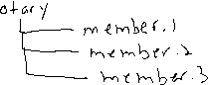

1. Describe what a command *DIR | SORT /R > Dirlis* does.

This command will take a snapshot of the current directory. Then, it will sort the command in reverse order. Then the command is redirected to the Dirlis file.

1. Optional. Briefly describe any issues with the commands which did not work. Point me to the specific pages and suggest changes. Thanks.

The copy commands and the redirecting commands had issues finding the correct directories. Maybe a windows 10 thing, I’m unsure.